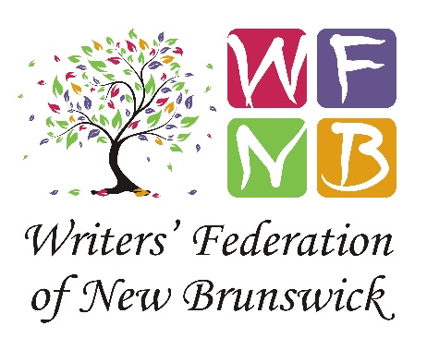
Executive Director
The Writers’ Federation of New Brunswick

The Writers’ Federation of New Brunswick (WFNB) is seeking a part-time Executive Director, 20 hours per week. The position can be conducted from a home office and has the potential to grow. As the face of a non-profit arts organization, the Executive Director will realize the Federation’s objectives with the direction and support of the WFNB’s board of directors.

The WFNB is a membership organization that has existed to nurture, support, and encourage New Brunswick writers at all stages of development since 1985. The successful candidate will continue that tradition by organizing annual member events throughout the calendar year, including Wordspring, Wordsfall, and our well-known NB Writing Competition, and managing our membership software and website. The Executive Director will also focus on fundraising, grant applications, and opportunities for income generation that are not government dependent.

Qualifications
- Event and project management skills and experience
- Working knowledge of Excel for bookkeeping purposes
- Comfort with Zoom software for meetings and events
- Strong organizational mindset, capable of juggling demanding tasks
- A self-starter who is comfortable with working alone but can reach out for advice and help when needed
- A connector and networker who displays excellence regarding membership engagement
Assets
- Bilingualism, communications/marketing experience, website and volunteer management, and experience with Wild Apricot membership software.
- Experience with grant writing and fundraising.
Salary is $23-$28,000 a year, commensurate with experience. Please direct resumes, with references, to: info@wfnb.ca
This position requires contact with the public on occasion; successful candidates will need to supply updated proof of vaccination against COVID-19 as a condition of employment. Applications will be reviewed on an ongoing basis, so early submission is encouraged. Deadline: December 13, 2021.
We thank everyone who applies for their interest in this position; however, only candidates selected for an interview will be contacted.

