CALL FOR ARTISTS
PUBLIC ART PROJECT
Deadline : November 26, 2021
The Mgr. W.J. Conway Public Library Board is seeking proposals from artists, collectives and arts organizations to propose a public art project, mural, etc. as part of our public library’s 50th anniversary.
The latter are invited to propose a permanent art installation or mural near the building. Given the heritage status of the building, the work cannot be installed on the components of the building and must be installed on a freestanding support of ‘’Marine Grade’’ type to ensure its longevity.
TERMS OF THE APPEAL – Public art project
Place: Edmundston, Mgr. W.J. Conway Public Library
Duration: Three months
Fee : $3,000 - the artist is required to provide the accessories, supplies and equipment necessary for the production of the work, except for the freestanding support and its installation, subject to budgetary provisions. The installation and freestanding support equipment will be the responsibility of the Mgr. W.J. Conway Public Library and the City of Edmundston.

Eligibility: Professional and/or emerging artists and/or new artistic practice

Priorities: Candidates from and/or residents of the Edmundston or N.B. region and/or engaged in a professionalization process and/or recognized by their peers.
Content of the Proposal:
The proposal must include:
1. Coordinates (name, telephone, email, mailing address)
2. Detailed description of the project (maximum one page) + sketches, including dimensions (suggestion 20 feet width X 14 feet height)
3. Artist statement (maximum one page)
4. Artist Curriculum vitæ (max. 3 pages)
5. Artistic biography (max. 200 words)
6. Press kit (facultative)
7. Digital images and/or videos of works in JPEG format (maximum of ten)
8. Detailed list of images/videos (title, year, medium and dimensions)
Assessment Criteria
Artistic merit – 50 %
Addresses the priorities – 30 %
Professionalism of the proposal – 10 %
Ability to complete the project – 10 %

Selection Process
1. All submissions will be evaluated by the members of the board of directors and the management of the organization, as well as a professional member of the region’s artistic community.

2. The Mgr. W.J. Conway Public Library reserves the right to invite a potential candidate to submit his or her candidacy after the closure of registration, in the event that the applications received are insufficient in number, ineligible or non-priority and/or whose preliminary assessment is below the 70% mark.

3. The Mgr. W.J. Conway Public Library reserves the right to the final decision in order to ensure a balance between the different artistic styles, techniques and philosophies, as well as an equitable representation of the library's official languages, genres, cultural communities and strategic objectives.

4. Only selected candidates will be contacted.
Submission of Application
Send your proposal with the mention « Public Art, library – ARTIST’S NAME » by email to: (Odette Blier, omblier@gmail.com, Chair of the Mgr. W.J. Conway Public Library Board) by November 26th, 2021.
Information
For more information and/or to discuss your project, please contact Marc Cool, marc.cool@gnb.ca, Director of the Mgr. W.J. Conway Public Library.

Copyright
The artist retains his copyright but undertakes to assign the property and broadcasting rights to the Mgr. W.J. Conway Public Library, allowing it to reproduce the work without receiving any form of royalty, provided that the objective is not profit-making and commercial.

Location of the mural on the panel
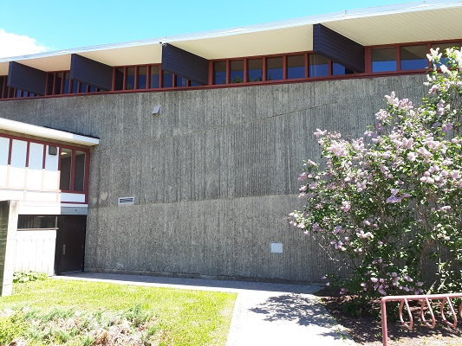
Location Information:
The Mgr. W.J. Conway Public Library, located on Irène Street in Edmundston, was built in 1966 and 1967 by renowned architect, artist and poet Roméo Savoie.
Roméo Savoie was born in 1928 in Moncton, New Brunswick. From 1959 to 1970, he worked as an architect in the province, including in Edmundston. He carried out and collaborated in the construction of some fifty buildings during his career. He is known as one of the builders of infrastructural development in Acadia with the creation of several art galleries, including Galerie Sans Nom and Galerie 12 in Moncton, as well as Galerie d'art Le Cavreau, formerly established in Edmundston.
Roméo Savoie has been the recipient of several awards, notably in 1999 with an honorary doctorate in visual arts from the Université de Moncton for a career devoted to contemporary painting. He is also the recipient of grants from the Canada Council for the Arts, New Brunswick and Quebec, as well as the Miller-Brittain Prize and the Strathbutler, to name a few. His works are part of the permanent collections of the Art Bank of the Canada and New Brunswick Council for the Arts, the Musée d'art contemporain de Montréal, the Musée national des beaux-arts du Québec, the Canadian Cultural Center at Paris, as well as the collection of the Université de Moncton and the University of New Brunswick.
Notre-Dame-du-Sacré-Cœur
The heritage building, Notre-Dame-du-Sacré-Cœur, testifies to its association with the brutalism architectural style resulting from the modern movement from 1950 to 1970. The style takes its name from the raw concrete.

The construction which is mainly in exposed concrete is widespread in the world of architecture strongly influenced by the French architect Le Corbusier, in the 20th century.
Concrete, due to its liquid nature, can take on any texture or pattern when poured over forms. The creation of Notre-Dame-du-Sacré-Cœur Church in Edmundston was strongly influenced by this movement and is an example of the dramatic potential of brutalism.
Roméo Savoie's trips to Europe in the 1960s, notably the visit to concrete architecture in Finland, inspired the slender and angular shape of Notre-Dame-du-Sacré-Coeur, with its free-standing bell tower which bears witness to the historical function of the building. The building was converted in 2000 into a library, which houses the fifth largest collection in New Brunswick, with more than 47,000 documents, over an area of ​​1,654 square meters.
Sources: Leroux, John, PhD, Building New Brunswick, An Architectural History, Goose Lane, 2008 (historicplaces.ca, consulted in 2021) (Image: Dr. John Leroux)
