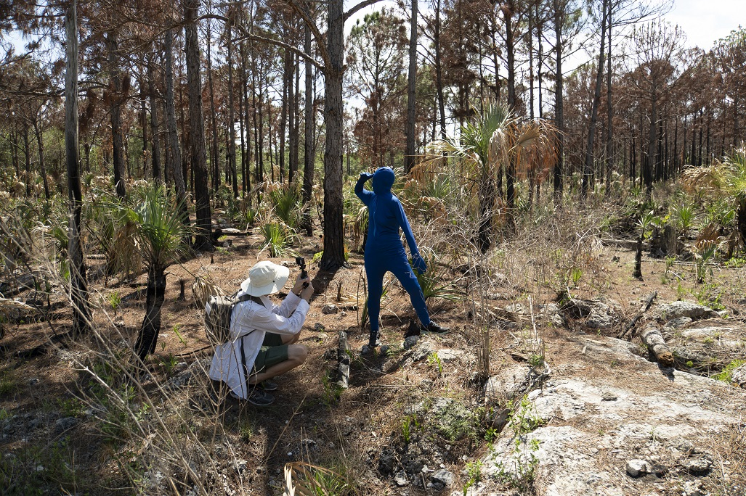

Habitat
Valerie LeBlanc and Daniel H. Dugas

November 6 to December 20, 2020

Valerie LeBlanc and Daniel H. Dugas, In the Pine Rocklands, 4K video

The Galerie d’art Louise-et-Reuben-Cohen presents Habitat, a new exhibition by artists Valerie LeBlanc and Daniel H. Dugas as part of the Festival International du cinema francophone en Acadie. The opening will be held on November 18, from 4 to 6 PM and there will be two presentations by the artists, at 4:30 and at 5:30 PM. (Please note that 40 people will be allowed inside the building at any given time).

Habitat is a trilogy of video, audio, and photo projects that have been produced in the context of artistic residencies in various nature reserves in South Florida. As introduced by the artists: "We explored each of these areas in turn with our cameras and audio recorders, often accompanying biologists and botanists in the performance of their duties. We tried to understand the reality of these places by remaining open to the spirits that inhabit them."

Curator Jonathan Lamy explains the artists' primary practice in this exhibition, videopoetry: "The artworks presented in Habitat are neither film nor cinema, but videopoetry. A hybrid practice, a genre which erases the boundary between video and poetry." The works in the exhibition thus manifest themselves in an association of images and texts that intermingle in the same space, and point to the place of human beings in nature.

Habitat will be presented from November 6 to December 20, 2020. Visiting hours are 1 – 4 PM, Tuesday to Sunday. Admission is free and all are welcome. The exhibition includes QR codes and visitors are encouraged to bring their smartphones as well as their ear buds to access the soundwalks. For those who don’t have built-in QR code readers, third-party applications can be downloaded from Google Play or the Apple Store.

Covid-19: Preventative measures are in effect, including regular disinfection and physical distancing.
To learn more about the gallery’s activities and programming: WWW. 