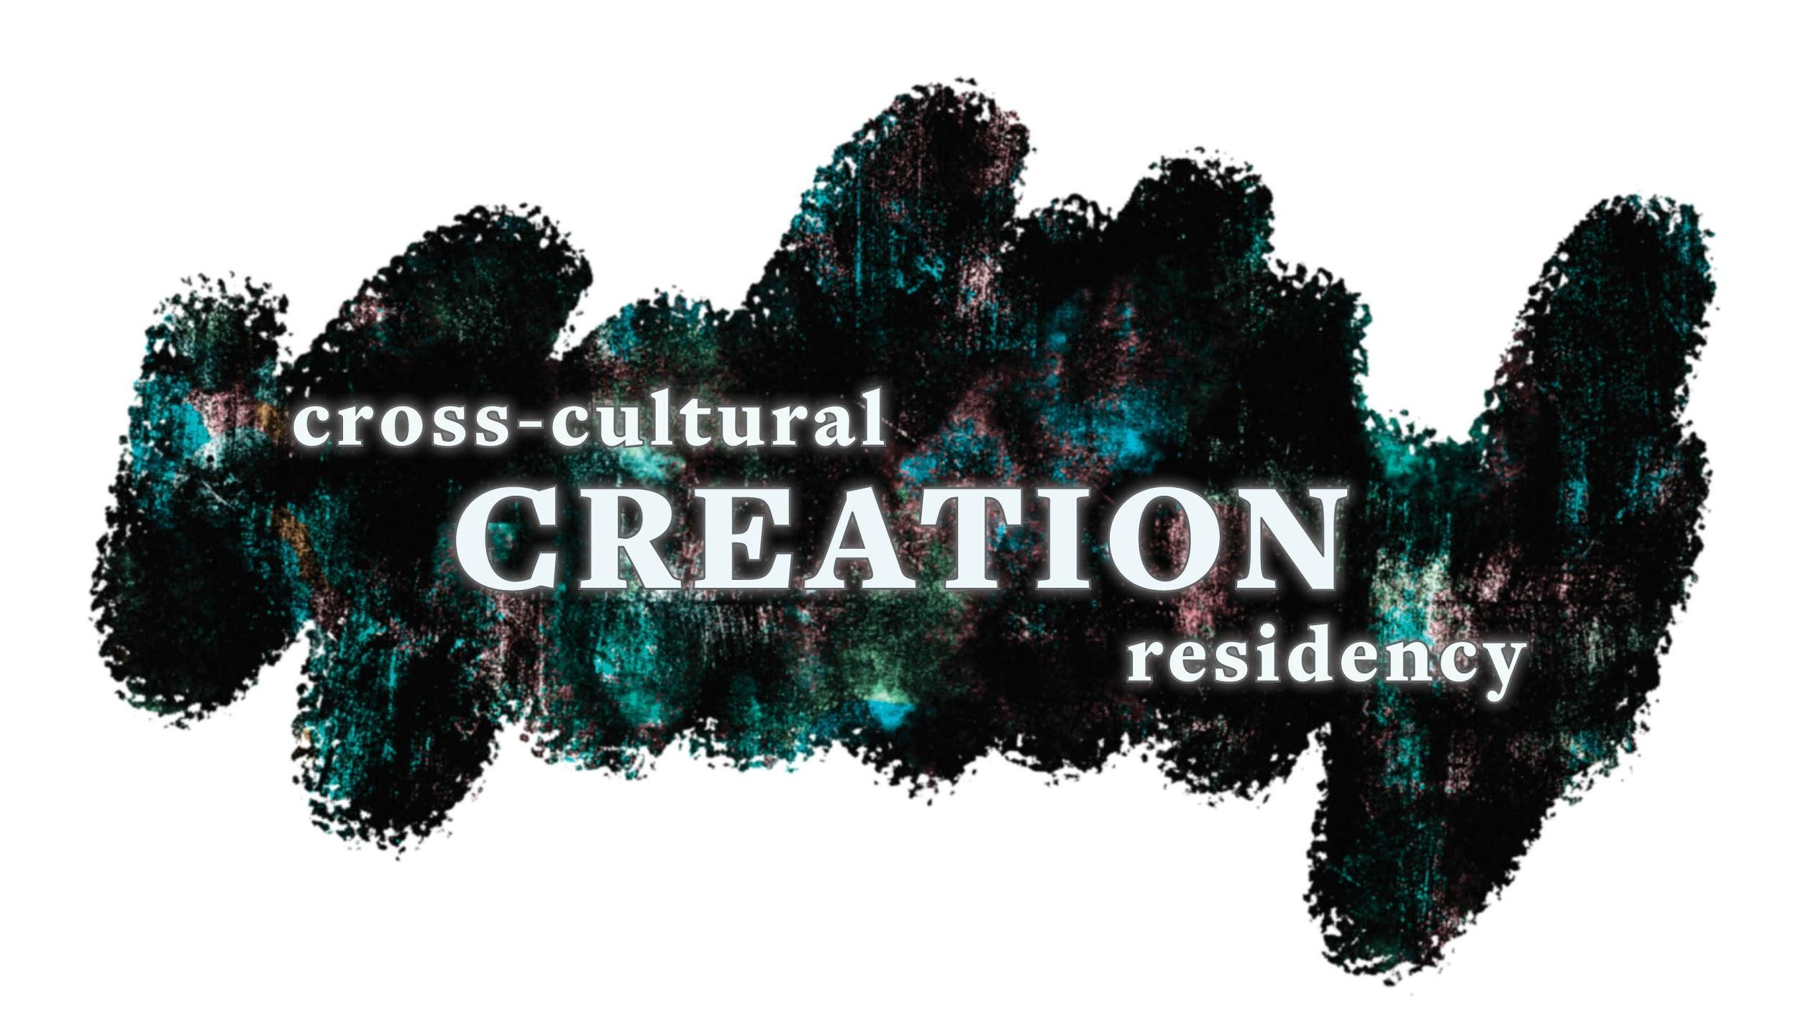

Cross-Cultural Creation Residency

A francophone artist
An anglophone Artist
An indigenous artist

Cross-cultural creation residency
The Association acadienne des artistes professionnel.le.s du Nouveau-Brunswick (AAAPNB), ArtsLink NB and Mawi'Art: Wabanaki Artist Collective, join forces again for the second Cross-cultural creation residency. A community residency between an Acadian artist, an anglophone artist, and an indigenous artist in New Brunswick.

This year’s program will take place in two week-long stages, in different NB communities. Through this residency, artists will have the opportunity to create new work while immersing themselves in the artistic process of fellow artists.

The experience of being in another community and creating with people of different artistic backgrounds allows one to go beyond language barriers and discover different cultural environments. Recognizing current debates surrounding cultural and language tensions in New Brunswick, this initiative demonstrates that it is possible to grow by combining strengths rather than advocating division. Art in itself is a means of expression and cohesion and makes it possible to break down the boundaries that all too often isolate us.

OBJECTIVES OF THE RESIDENCE

- To encourage the artistic exploration and the production of new works by providing space and time
- To contribute to increasing the artistic quality of the work
- To favour the collaboration and the sharing of expertise and experiences
- To create significant cultural bridges of different cultural communities in the province.
- To provoke encounters between artists and the public and to help raise awareness of the creative process.

The work in progress must be presented publicly at the end of each week. The artists will have complete freedom of creation, but will be called upon to open their creation space to allow the community to discover their work through open-studio visits.

THE SELECTED ARTISTS UNDERTAKE TO :

- Provide their own working materials
- Interacting with the participating artists
- Present publicly the work in progress at the end of each week in the form of an exchange with the public.
- Submit a final report to the AAAPNB, ArtsLink and Mawi’Art 30 days after the end of the residency.

WHO CAN REGISTER?

- This project is open to emerging and professional artists of all disciplines.
- This project is open to Acadian artists who are members of the Acadian Association of Professional Artists of New Brunswick, ArtsLink artists and Aboriginal artists.

HOW TO REGISTER ?

- Artists must register using the form below and answer all questions. A detailed description of the creation project is mandatory (minimum 500 words).
- Artists must submit, in addition to the completed form, their artistic approach and an updated curriculum vitae.
- The artists must be available for the duration of the residency, from March 15 to 28, 2020.

SELECTION CRITERIA

The applications will be examined by a jury of peers. The main qualities sought are:

- Feasibility of proposed project;
- Artistic merits and originality of the artistic approach;
- The potential impact of the project on the career of the artist.

SCHEDULE
Deadline to submit: Feb. 12, 2020

The candidates will get a reply before Feb. 19, 2020.

WHAT THE RESIDENCE INCLUDES

- A fee of $ 2,000
- Reimbursement for moving from the artists' residence to the places of the residences (beyond 50 km)
- Accommodation
- Per diem of food
- Creative premises

FOR INFORMATION

Annik Landry - Responsible for artist services
Association acadienne des artistes professionnel.le.s du Nouveau-Brunswick
140 rue Botsford, bureau 29, Moncton, NB, E1C 4X5
annik.landry@aaapnb.ca
506-852-3313 ext. 226
www.aaapnb. ca

Julie Whitenect - Executive Director
ArtsLink NB
89 Canterbury St., Suite 407, Saint John, NB, E2L 2C7
julie@artslinknb.com
506-608-9914
www.artslinknb.com

This project is a collaboration between ArtsLink NB, the Association acadienne des artistes professionnel.le.s du Nouveau-Brunswick and Mawi'Art: Wabanaki Artist Collective and is made possible thanks to the support of the government of New Brunswick.
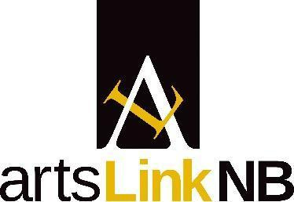
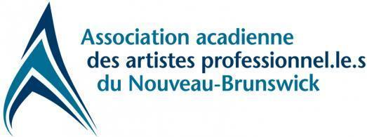
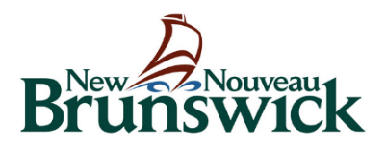
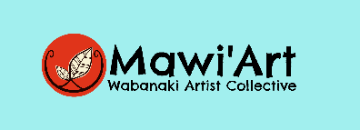
REGISTRATION FORM

1. IDENTIFICATION

Last name: First name:
Address (street no.): City:
Province: Country: Postal code:
Telephone number: Home:() Work: ()
E-mail: ___________________________
Primary language: Spoken languages:

2. PROPOSED PROJECT

Describe the project you intend to develop during the residency, as well as impact it may have on your career. Be sure to explain the feasibility of the project. (Minimum 500 words)

3. EDUCATION

Indicate, if applicable, the last diploma you obtained, specify the year of obtaining and the name of the establishment.

DIPLOMA | YEAR OF ACHIEVEMENT | NAME OF INSTITUTION | CITY
University of
2nd or 3rd cycle.
University
1st cycle
diploma
College
Diploma from a
private art school
training
Self-taught

5. PROFESSIONAL ACTIVITIES

Have you exhibited or presented your creative work in a professional context?

YES NO

If yes, please mention the year, the name of the establishment and the city where the presentation took place.

NAME OF ESTABLISHMENT | CITY | YEAR

6. ADDITIONAL INFORMATION

Describe the reasons why you are interested in participating in this residence, as well as the benefit(if any) to the community at large.

I acknowledge having read the requirements and eligibility criteria inherent in this request and having provided accurate information.

In witness whereof, I have signed this day of 2020.

Signature: __________________________

